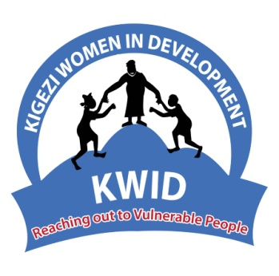 KIGEZI WOMEN IN DEVELOPMENT (KWID)

P.O.BOX 894 Kabale

kwid1996@gmail.com

[www.kwidug.org](http://www.kwidug.org)

**The British High Commission**

**PO Box 7070,**

**Kampala, Uganda,**

**Dear Sir/Madam,**

Re: ​**CHEVENING SCHOLARSHIP RECOMMENDATION FOR MR.** **LIBERTY CHRISTOPHER**

I am writing to you in support of **Liberty Christopher’s** application for the prestigious UK Government Chevening Scholarship. Christopher has been a Projects Officer with Kabale Women in Development (KWID) since 2017, and I directly supervise his work. As a project officer for the past 5 years, he has excellently led teams to effectively execute assigned duties assigned to him. He has been directly involved with organising project activities, developing new projects to support our core objectives, budgetary management, and funding proposal writing.

For the years I have known him, he has consistently performed his duties with diligence, often beyond his prescribed tasks. For instance, **Mr. Liberty** spearheaded the successful implementation of a USAID funded Integrated health project where 39,400 people received HIV testing services. The project boosted HIV testing rates among adolescents and vulnerable groups and contributed to the reduction of HIV infection rates.

He also successfully wrote a grant proposal for the Menstrual Health Project. This project enabled KWID to keep in school girls from 112 rural schools in South Western Uganda. Furthermore, he has been at the forefront of our “16 days of activism against gender-based violence” campaigns in Kabale district since 2018. During these advocacy engagements, he has passionately shared his thoughts on gender equality as a cornerstone for socioeconomic transformation. **Mr. Liberty** is a great communicator, team player and he utilises his network for both his professional growth and community development. He further possesses the intellectual curiosity to excel during his planned Postgraduate study.

I have learned that Chevening Scholars are passionate, and influential leaders working to create a better future. **Mr. Liberty** fits these attributes perfectly. He has enthusiastically empowered vulnerable persons especially the women and girls under KWID’s programmes. This makes him a perfect fit for the Chevening Scholarship. Women and girls are not well integrated into development programmes in Uganda. We need well-trained and passionate young leaders to spearhead programmes that tackle gender inequality and other societal challenges. I confidently recommend **Mr. Liberty** for the Chevening scholarship to pursue M.Sc. Development Management. I am certain that he will return home after his studies and contribute his development skills to further KWID’s strategic goal targeting gender equality, education, Health and wellbeing, and poverty eradication. In a few years from now, **Mr. Liberty** will be a global gender equality champion and a leader in the international development sector

I have every confidence that he will thrive in a graduate school setting. His intelligence, ability to work in groups and to perform in a competitive environment makes him the perfect candidate for the Chevening Award. It is always a joy working with **Mr. Liberty**, and I am proud to be able to provide this letter of recommendation.

I can be reached at [director@kwidug.org](mailto:director@kwidug.org), [kwid1996@gmail.com](mailto:kwid1996@gmail.com) or +256772428430 /+256758670041 if you have any questions regarding his application.

Yours Sincerely,

**…………………………………….**

Tumuheirwe Florence

Executive Director

Kabale Women in Development